## 

## **Rev those engines… It's Nintendo Society News Time!**

Exams are looming closer, so we wish everyone good luck and hope they go well! But we’ll still be around to help with the all-important exam de-stressing!

And with that, here are this week's announcements:

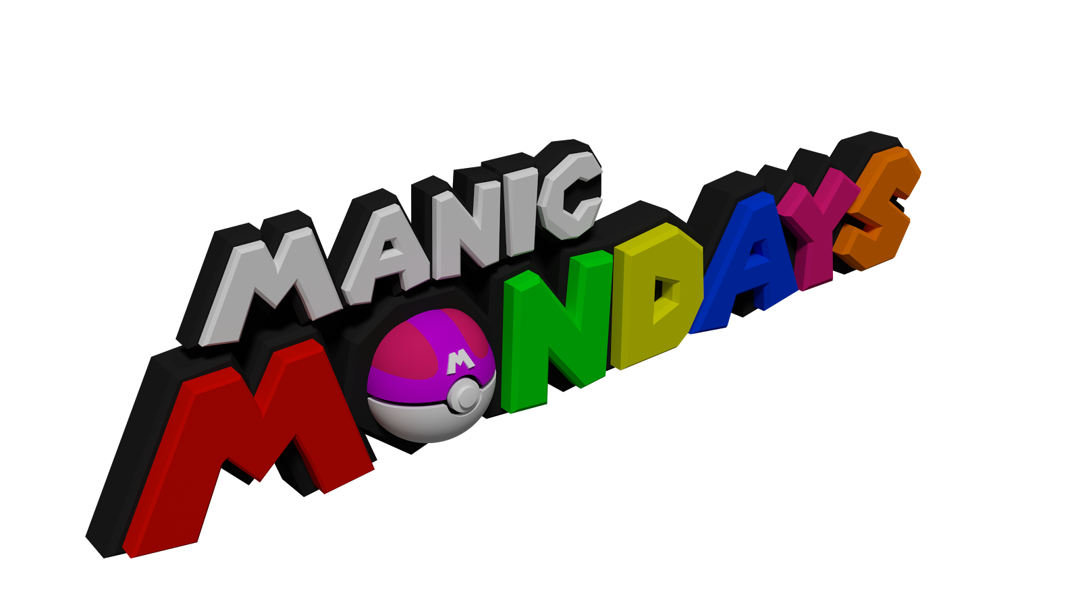

### **Monday 15/5, R1.03, 6pm onwards**

Local multiplayer at its finest; this week includes Mario Kart 8 Deluxe, Minecraft, Puyo Puyo Tetris, Super Mario Sunshine Multiplayer and more! Come along!

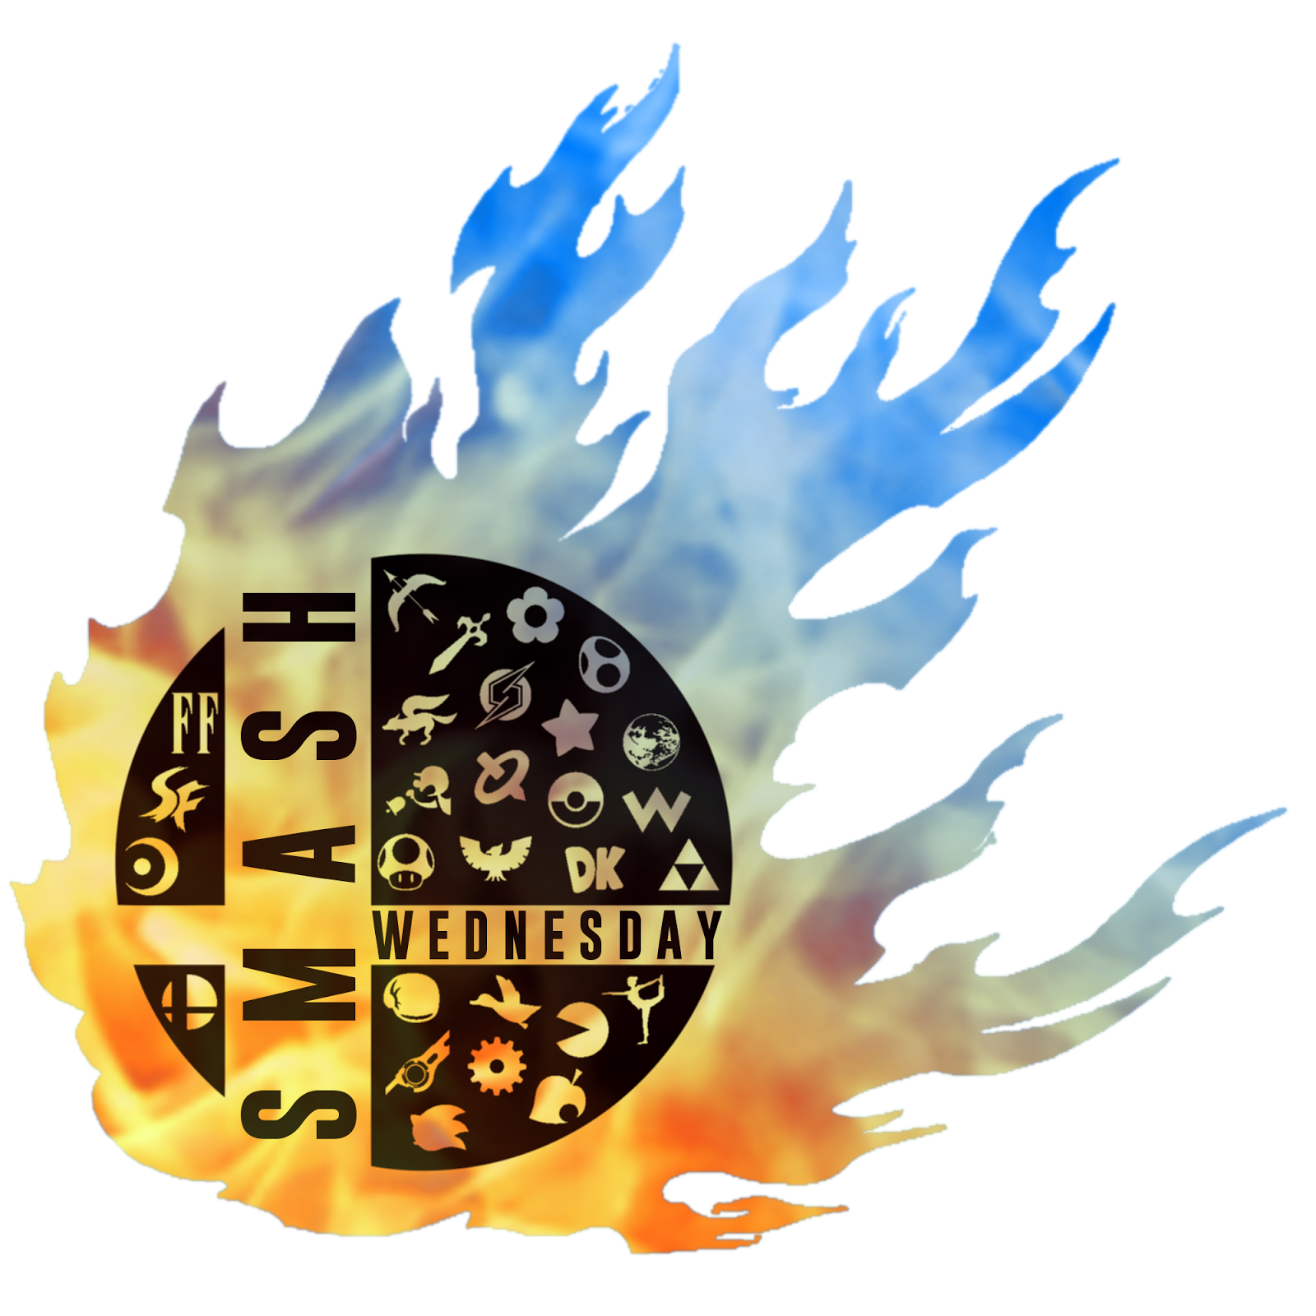

### **Wednesday 17/5, R1.04, 2pm onwards**

Our weekly Smash event returns! Potentially with mods! Come along to destress from term 3 revision and have fun!

---------------------------------------------------------------------------------------

Well then, folks, until next time, staaaay fresh!

And Happy Gaming! :D

Timothy Sit

Nintendo Society President

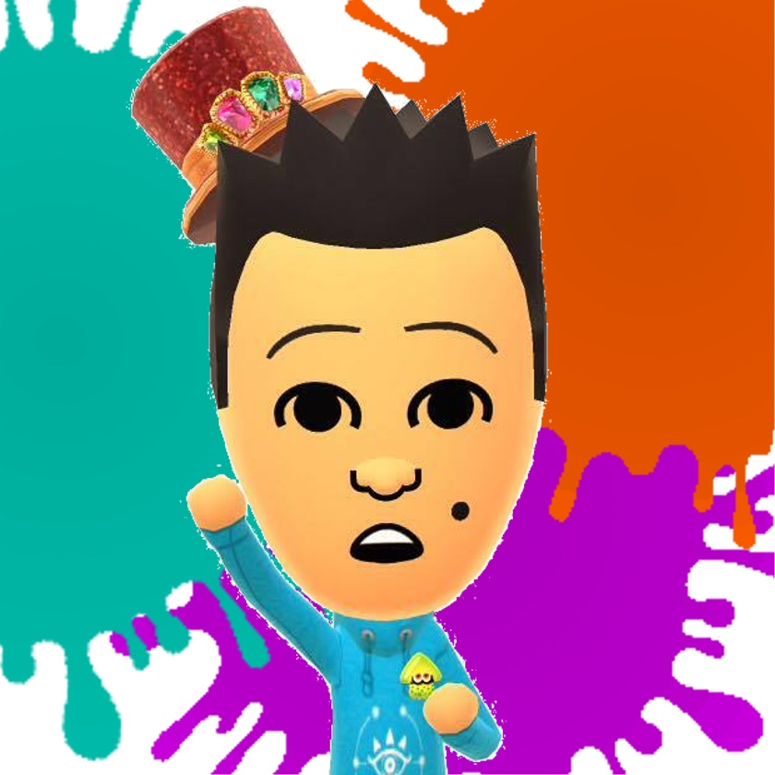

---------------------------------------------------------------------------------------

### **Find us on Social Media:**

Join our Facebook group:<https://www.facebook.com/groups/warwicknintendo/>

Follow our Twitter:<https://twitter.com/warwicknintendo>

Join our Discord Chat:<https://discordapp.com/invite/Rf6QyfG>

Subscribe to our YouTube:<https://www.youtube.com/channel/UCzO_bZNfQDCAQa_zkEUgGVg>